Case 3-Eur-Spain-Engraved Plaque-Anthropomorphic-Slate-3450-2750 BCE

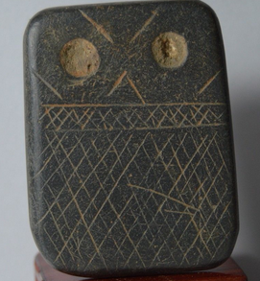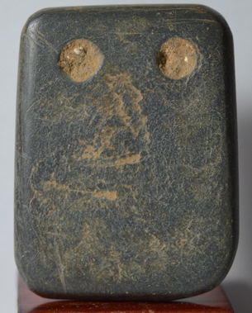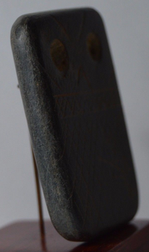

Figs 1-3. Iberian Engraved Plaque-Anthropomorphic-Slate-3450-2750 BCE

**Case no.: 2**

**Accession Number:**

**Formal Label:** Iberian Engraved Plaque-Anthropomorphic-Slate-3450-2750 BCE

**Display Description:**

Southwestern Iberian (i.e. Southern Portugal and nearby areas of Spain) engraved stone plaques from megalithic funerary monuments dating ca. 3,450–2,750 BCE (calibrated ages) exhibit a common cultural communication system. Apparently, plaques were developed on a basic design grammar, with variable design elements such as caps, eyes, eye brows, and hands, but these variations do not represent any genealogical basis as there is little or no geographical cohesion to the clustering of these specific design features.

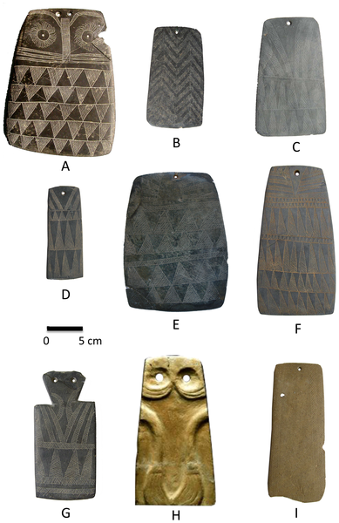

Fig. 4. Different designs of Iberian Chalcolithic plaques after http://journals.plos.org/plosone/article/figure/image?id=10.1371

**LC Classification:** GN835.S35

**Date or Time Horizon:** Chalcolithic, 3,450–2,750 BCE

**Geographical Area:** Portalegre District in the Alentejo area of south-central Portugal.

**Map:**

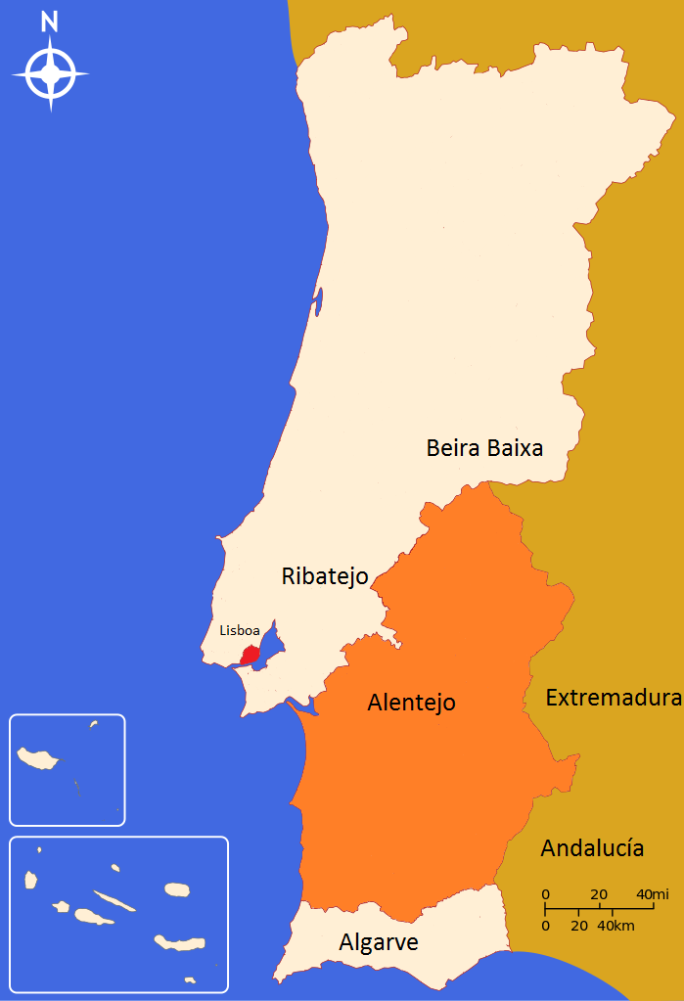 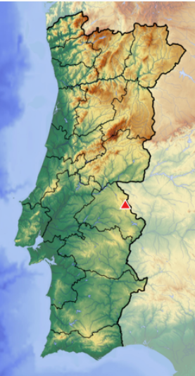

Fig. 5. Alentejo area in Portugal By Urgup-tur - Own work, CC BY-SA 4.0, <https://commons.wikimedia.org/w/index.php?curid=43089658>

Fig. 6. Portalegre District in the Alentejo area of Portugal after https://upload.wikimedia.org/wikipedia/commons/thumb/0/08/Portugal_location_map_Topographic.png/248px-Portugal_location_map_Topographic.png

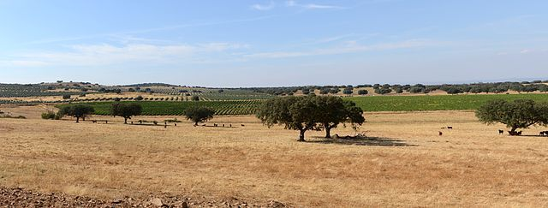

Fig. 7. Typical Alentejo landscape (CC by Alvesgaspar) Cork oak trees are in the foreground (*Quercus suber*), in a harvested wheat field. Beyond these are vineyards (*Vitis vinifera*) and olive trees (*Olea europea*. After https://i2.wp.com/upload.wikimedia.org/wikipedia/commons/thumb/2/24/Alentejo_September_2013-1.jpg/640px-Alentejo_September_2013-1.jpg?zoom=2

**GPS coordinates:** [39°17′N 7°21′W](https://tools.wmflabs.org/geohack/geohack.php?pagename=Serra_de_S%C3%A3o_Mamede&params=39_17_N_7_21_W_type:mountain_dim:13km)

**Cultural Affiliation:** Iberian Chacolithic

**Medium:** silicified sandstone

**Dimensions:** 4.8 x 3.7 cm

**Weight:**

**Condition: original**

**Provenance:** from an old Belgian collection. Similar to the collection of Leon Levy & Shelby White

**Discussion:**

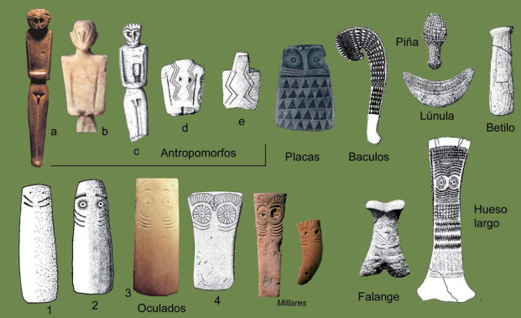

Fig. 8. Diverse types of figurines from Chalcolithic Iberia after <http://3.bp.blogspot.com/-0d_E0hxg4y4/Tg2RC12l6JI/AAAAAAAAAec/rxtAEz-VFfE/s320/Clasesdeidolillos.webp>

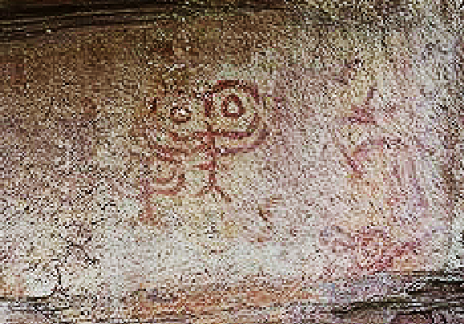

Fig. 9. Chacolithic rock art from Abrigo de los Oculados Henarejos, Cuenca province, Spain, of the schematic style, possibly IVb. After <http://4.bp.blogspot.com/-yqkUF3EeozY/T98FuRwnIxI/AAAAAAAADeo/rNemjzylTjU/s1600/Abrigo+de+los+Oculados.jpg>

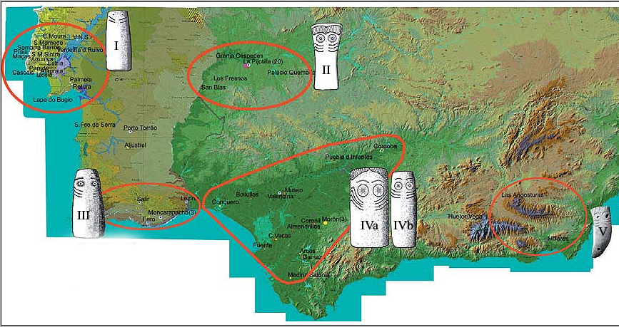

Fig. 10. Five zones of different Iberian Chacolithic Eye Plaques. After http://3.bp.blogspot.com/-UCvxmn7GArU/Tg2QVQxuRQI/AAAAAAAAAeY/b8GC-WxD0qQ/s1600/IdolosOculadosAndalucia.webp

The dates for this Iberian Engraved Plaque overlap with the known dates for the Chacolithic Los Millares culture (c 3200–2300 BCE) and its “Almeriense” precursor culture in the municipality of Santa Fe de Mondújar, [Andalucía](https://en.wikipedia.org/wiki/Andaluc%C3%ADa), southeastern Spain. The Chacolithic Los Millares culture probably supported ca 1000 people (Cunliffe 2008: 144; Peregrine and 2001).

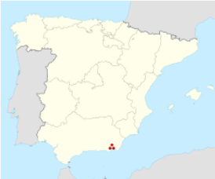 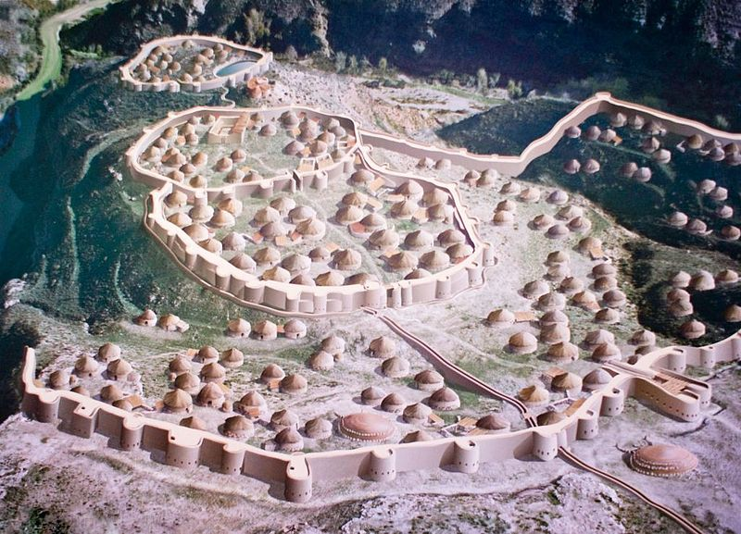

Fig. 11. [Santa Fe de Mondújar](https://en.wikipedia.org/wiki/Santa_Fe_de_Mond%C3%BAjar), [Province of Almería](https://en.wikipedia.org/wiki/Province_of_Almer%C3%ADa), [Andalusia](https://en.wikipedia.org/wiki/Andalusia), [Spain](https://en.wikipedia.org/wiki/Spain) [36°57′53″N 02°31′20″W](https://tools.wmflabs.org/geohack/geohack.php?pagename=Los_Millares&params=36_57_53_N_02_31_20_W_type:landmark) after https://upload.wikimedia.org/wikipedia/commons/thumb/8/88/Spain_location_map.svg/250px-Spain_location_map.svg.png

Fig. 12. By Jose Mª Yuste, de la fotografía (Tuor123). Miguel Salvatierra Cuenca, autor de la ilustración - Own work, CC BY-SA 4.0, https://commons.wikimedia.org/w/index.php?curid=5505410

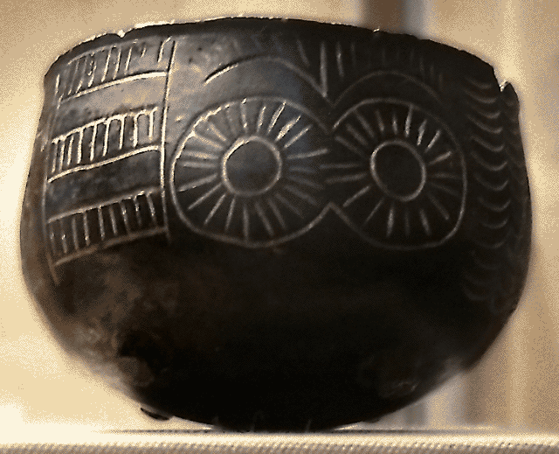

Fig. 13. Reproduction of a Millarense bowl with the typical *eyes* motif of the chalcolithic of SE Iberia **after** José-Manuel Benito Álvarez https://upload.wikimedia.org/wikipedia/commons/a/a0/Cuenco_de_Los_Millares.png

**Discussion:**

This Late Neolithic engraved slate plaque ca. 3,500–2,750 BCE (calibrated age) from La Pijotilla2, Badajoz, Spain (southwest Iberian Peninsula) has three registers: a lower register of six levels of cross-hatcheurs, a middle register of two cross-hatcheurs set off by horizontal lines and an upper register of “eye” designs with a drilled hole through which strings were passed (based on use-wear analysis) so that it was worn as an amulet. While each of the six to ten “styles” of these slate plaques is distinctive in its specific details, each style exhibits a consistency in basic form, structure, and grammar.

The emergence of craft specialization in Late Neolithic Iberia reflects a shift in growing cultural stability in which various tribal groups began to coalesce around identities of social expression. These identities are reflected in the expressions of grammars of design incorporated into these engraved slates. The social shift underlying these design grammars represents articulation of social identities of several groups to a coalescence of these groups into cultural nodes reflective of fewer identities (Clark and Blake 2004; Flad and Hruby 2007; Helms 1993; Sennett 2008).

REFERENCES

Bibliography of Iberian Plaque Studies

Åberg, N. (1921). Civilisation énéolithique dans la péninsule ibérique. Uppsala, A.-b. Akademiska bokhandeln i kommission.

Almagro Gorbea, M. J. (1973). Los Idolos del Bronce I Hispano. Madrid, Consejo Superior de Investigaciones Científicas.

Ameghino, F. (1879). "L'homme préhistorique dans La Plata." Revue d'Anthropologie **2**: 210-249.

Breuil, H. (1935). Les peintures rupestres schématiques de la Penínsule Ibérique. Paris.

Bueno Ramírez, P. (1992). "Les plaques décorées alentéjaines: approche de leur étude et analyse." L’Anthropologie **96**(2-3): 573-604.

Carpenter, E., Ed. (1986-1988.). *Materials for the study of social symbolism in ancient & tribal art : a record of tradition & continuity/ based on the researches & writings of Carl Schuster*. New York, Rock Foundation.

Cartailhac, E. (1886). *Les âges préhistoriques de l'Espagne et du Portugal*. Paris: Ch. Reinwald.

Correia, V. (1917). "Arte pré-histórico: os idolos-placas." Terra Portuguesa **12**: 29-35.

Correia, V. (1921). *El Neolítico de Pavía*. Madrid, Museo Nacional de Ciencias Naturales.

Cunliffe, Barry. 2008. Europe Between the Oceans, 9000 BC-AD 1000.  New Haven: Yale University Press.

Frankowski, E. (1920). *Estelas Discoideas de la Península Ibérica*. Madrid, Museo Nacional de Ciencias Naturales.

Gimbutas, M. (1991). *Civilization of the Goddess: The World of Old Europe*. San Francisco, HarperSanFrancisco.

Gonçalves, V. S. (1999). *Reguengos de Monsaraz: Territórios Megalíticos*. Lisbon, Câmara Municipal de Reguengos de Monsaraz.

Leisner, G., and Vera Leisner (1943). *Die Megalithgräber der Iberischen Halbinsel. Der Süden*. Berlin, Walter de Gruyter.

Leisner, G., and Vera Leisner (1951). *Antas do Concelho de Reguengos de Monsaraz*. Lisbon, Uniarch.

Leisner, G., and Vera Leisner (1956). *Die Megalithgräber der Iberischen Halbinsel*. Der Westen. Berlin, Walter de Gruyter.

Leisner, G., and Vera Leisner (1959). *Die Megalithgräber der Iberischen Halbinsel*. Der Westen. Berlin, Walter de Gruyter.

Leisner, V. (1965). *Die Megalithgräber der Iberischen Halbinsel. Der Westen*. Berlin, Walter de Gruyter.

Leisner, V. (1998). *Die Megalithgraber der Iberischen Halbinsel: Der Westen*. Madrider Forschungen Vol. I, 4. Berlin, Walter de Gruyter.

Lillios, K. T. (2002). "Some new views of the engraved slate plaques of southwest Iberia," *Revista Portuguesa de Arqueologia* **5**(2): 135-151.

Lillios, K. T. (2003). *Creating memory in prehistory: the engraved slate plaques of southwest Iberia. Archaeologies of Memory. R. van Dyke and S. Alcock*. Oxford, Blackwell**.**

Lisboa, I. M. G. (1985). "Meaning and messages: mapping style in the Iberian Chalcolithic," *Cambridge Archaeological Review* **4**(2): 181-196.

Morgan, J. d. (1897). *Récherches sur les origines de l'Égypte*. Paris, E. Leroux.

Mortillet, G. de, and Adrien de Mortillet (1881). *Musée préhistorique*. Paris, C. Reinwald.

[Peregrine, Peter Neal](https://en.wikipedia.org/wiki/Peter_N._Peregrine); [Ember, Melvin](https://en.wikipedia.org/wiki/Melvin_Ember), eds. 2001. Encyclopedia of Prehistory. 4: Europe. New York: Springer.

Ribeiro, C. (1878-1880). *Estudos prehistoricos em Portugal; noticia de algumas estações e monumentos prehistoricos, memoria apresentada á Academia real das sciencias de Lisboa.* Lisbon, Typ. da Academia.

Rodrigues, M. da C. M. (1986). *Código Para a Análise das Placas de Xisto Gravadas do Alto Alentejo*. Castelo de Vide, Câmara Municipal de Castelo de Vide.

Rodrigues, M. da C. M. (1986). *Estudo Ideológico-Simbólico das Placas de Xisto Gravadas.* Castelo de Vide, Câmara Municipal de Castelo de Vide.

Ruiz, Juan F. , Antonio Hernanz, Ruth Ann Armitage, Marvin W. Rowe, Ramon Viñas, José M. Gavira-Vallejo, Albert Rubio, Calcium oxalate AMS 14C dating and chronology of post-Palaeolithic rock paintings in the Iberian Peninsula. Two dates from Abrigo de los Oculados (Henarejos, Cuenca, Spain),” *Journal of Archaeological Science*, 39(8), August 2012, Pages 2655-2667, ISSN 0305-4403, 10.1016/j.jas.2012.02.038. (<http://www.sciencedirect.com/science/article/pii/S0305440312001240>)

Simões, A. F. (1878). Introducção a archeologia da Peninsula Iberica. Lisbon, Livraria Ferreira.

Siret, H., and Louis Siret (1887). *Les premiers âges du métal dans le sud-est de l'Espagne*. Anvers.

Siret, L. (1913). *Questions de chronologie et d'ethnographie ibériques*. Paris, Paul Geuthner.

Vasconcellos, J. L. de and Sociedade de Geografia de Lisboa. (1897). *Religiões da Lusitania na parte que principalmente se refere a Portugal*. Lisboa, Imprensa Nacional.

Vasconcellos, J. L. de (1906). "Portugalia." *O Arqueólogo Portugês* **11**: 321-379.

Veiga, S. P. M. E. da (1887). *Antiguidades monumentaes do Algarve: tempos prehistoricos*. Lisboa, Imprensa nacional.